Content:
Production of low temperature - Joule Thomson effect, Porous plug experiment, Linde’s air liquefier, Liquefaction of Helium. Adiabatic demagnetization, Applications of Cryogenics, in Aerospace, Tribology and Food processing (qualitative), Numerical Problems.
Thermo-electric materials:
Thermo-emf and Thermo-electric current, Seebeck effect, Peltier effect, Thermo-couples, Thermo-pile, Construction and Working of Thermo-electric generators (TEG) and Thermo-electric coolers (TEC), Numerical Problems.
Cryogenics:

Thermo-emf and Thermo-electric current:
When two dissimilar metals are joined at their ends to form two junctions and if these two junctions are maintained at two different temperatures a current is found to flow in the closed circuit and hence emf is produced. The emf is called Thermo-emf and current is known as Thermo-current. Thermo-emf is an electromotive force which is generated due to the thermal gradient.
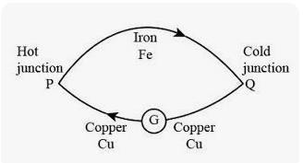

In figure we have 2 thermally and electrically conducting Copper and Iron wires. The 2 wires are attached terminal to terminal to become a closed circuit. A galvanometer is attached to the circuit to detect any current flow through the circuit. The junction P is the hot terminal where the temperature is comparatively higher as compared to the cold terminal which is Q.
We know that electrons flow from a denser electron metal to a lower electron denser metal, thus creating a gradient. So, if temperature of the junction is maintained at 2 different values, electron diffusion happens, which generates larger potential at the hotter junction when compared to the colder junction. This variation in potential creates a flow of current, which is detected by the galvanometer. The existence of current flow indicates that an emf exists in the circuit.

Seebeck effect:
Definition: The production of electromotive force (emf) and hence current by maintaining the junctions of two dissimilar metals at different temperatures is called Seebeck effect.
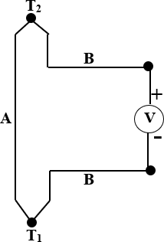
In 1821 Thomas Johann Seebeck discovered this phenomenon. The emf is known as Thermo-electric emf. The Thermo-electric emf causes a continuous current in the conductors, if they form a complete loop and the current is known as Thermo-electric current. The voltage (Thermo-electric emf) created is of the order of several micro volts per kelvin difference.

The Thermo-electric emf will exist and the current will flow in the circuit as long as the 2 junctions, known as the “hot” junction and “cold” junction, are at different temperatures. Thus, the Seebeck effect is the conversion of temperature differences directly into electricity. The magnitude and direction of the Thermo-electric current depends on the types of metals used and the temperature between the hot and cold ends. It does not depend on the temperature distribution along the conductors.

The voltage developed in the circuit, is proportional to the temperature difference between the 2 junctions.
𝑉 = 𝛼 (𝑇2 − 𝑇1)
Where 𝛼 = 𝛼_{𝐵} − 𝛼_{𝐴}
𝛼_{𝐴} 𝑎𝑛𝑑 𝛼_{𝐵} are known as the Seebeck coefficients of the metals A and B, and T₁ and T₂ are the temperatures of the two junctions.
Seebeck effect is observed not only in metals but as well in semiconductors also. It is not necessarily a junction phenomenon, but arises in a single conductor also. If temperature gradient (difference) is caused in conductor, electrons diffuse from the hot side to the cold side. Electrons migrating to the cold side leave behind their oppositely charged and immobile nuclei on the hot side and thus give rise to a Thermo-electric voltage.

Seebeck coefficient:
Seebeck coefficient or Thermo-power of a material measures the magnitude of an induced Thermo-electric voltage in response to a temperature difference across that material. It is defined as the open circuit voltage produced between two points on a conductor, where a uniform temperature difference of 1K exists between those points.
If the temperature difference ∆T between the two ends of a material is small, then the Thermo-power or Seebeck coefficient of a material may be written as
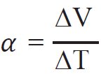
This can also be expressed in terms of the electric field E and the temperature gradient ∇𝑇,

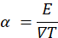
Peltier Effect:
In 1834 Peltier discovered that when electric current passed in a circuit consisting of two dissimilar metals, heat is evolved at one junction and absorbed at the other junction. This is known as Peltier effect.
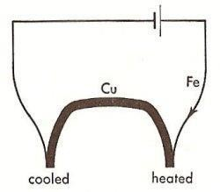
It is the inverse of the Seebeck effect. The Peltier effect is a junction phenomenon. There is heat absorption or generation at the junctions depending on the direction of current flow. Heat generated by current flowing in one direction was absorbed if the current was reversed.

Example: Consider the circuit as shown in the figure. Under these conditions it is observed, as indicated in the diagram, that the right-hand junction is heated, showing that electrical energy is being transformed into heat energy. Meanwhile, heat energy is transformed into electrical energy at the left junction, thereby causing it to be cooled. When the current is reversed, heat is absorbed at the right junction and produced at the left one.
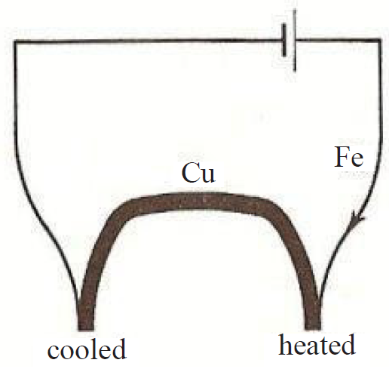

Peltier Coefficient:
The Peltier coefficient is defined as the amount of heat energy absorbed or evolved at the junction of two dissimilar metals when one ampere of current flows through it for one second. It is denoted by π and expressed in volts. It is a property that depends on both materials of the junction.
The heat absorbed per second at a junction carrying a current I amperes is given by
Heat absorbed per second = π_{ab} I ------- (1)
Heat absorbed in t seconds, H = π_{ab} I t = π_{ab} q ------- (2)
Where current is from metal ‘a’ to metal ‘b’.
The junction emf, π_{ab} is known as Peltier coefficient.
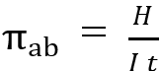
π_{ab} is positive if metal a is positive with respect to metal b (thus π_{Cu-Fe}is positive).
The magnitude of π_{ab} is a function of the temperature of the junction. For identical temperatures π_{ab}= - π_{ba}. Thus, if the direction of the current in the equation (1) is reversed, the heat absorbed per second is
Heat absorbed per second = -π_{ab} I, which is opposite in equation (1).
If V is the potential difference applied,
then Heat absorbed = V q = V It
Equating the above with equation (2), we get π = V
Thus, the Peltier coefficient is numerically equal to the applied potential difference expressed in volts.

Thermo-couples:
A Thermo-couple is a transducer that converts thermal energy into electrical energy and is constructed by joining wires made from dissimilar metals to form a junction. Voltage is produced when the temperature at the junction changes.
Principle: The concept of the Thermo-couple is based on the Seebeck Effect, which states that if dissimilar metals are joined at a point, they will generate a small measurable voltage when the temperature of the point of connection changes. The amount of voltage depends on the amount of temperature change and the characteristics of the metals.
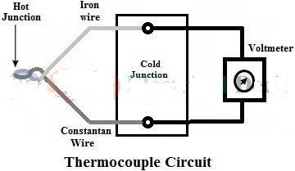
Construction: Thermo-couples are constructed by two different metals that exist in the form of wires. The two ends are joined by twisting the two wires and welding them together. The figure shows the Thermo-couple formed by two dissimilar metals i.e. Iron and Constantan. A protective sealing is provided around the junction and a portion of extension leads. Generally, a diameter of wire ranging from 1.5 to 3mm is used for base metals and a diameter of 0.5mm wire is used for noble metals.
Working:
In a Thermo-couple transducer, out of two junctions, one junction is referred to as hot junction or measuring junction, which is placed at the process media where the temperature is to be measured. Another junction is referred to as a cold junction or reference junction is maintained at a constant reference temperature.
When there exists a temperature difference between hot and cold junctions an emf will be set up at the free ends due to temperature gradient and is measured by millivoltmeter. The amount of induced emf depends upon the difference in temperature between two junctions and the material used to build the Thermo-couple.
The temperature is determined by calibrating the millivoltmeter. Since the cold junction is at 0°C, the induced emf measured by the voltmeter is the function of the temperature of the hot junction. It is essential to keep the reference junction at 0°C to avoid errors due to change in room temperature.

Advantages of Thermo-couple:
- It is an active transducer i.e. it operates without any external power source.
- Measurement of wide ranges of temperature from -200°C to 2800°C.
- The response time is fast, which can measure fast-changing temperatures.
- The cost of Thermo-couples is low compared to thermistors.
- Able to measure temperatures at desired points.

Disadvantages of Thermo-couple:

- The output voltage produced is low.
- Stray magnetic field can introduce errors in output voltage.
- Accuracy is low.

Thermo-pile:
A Thermo-pile is an electronic device that converts thermal energy into electrical energy. It is composed of several Thermo-couples connected usually in series or, less commonly, in parallel.
Principle: Principle is Thermo-electric effect, i.e., generating a voltage when its dissimilar metals (Thermo-couples) are exposed to a temperature difference i.e. Seeback effect
Construction:
The structure of the Thermo-pile is shown in figure. The output voltage of a single Thermo-electric cell is extremely small. So, a number of these cells is connected in series/parallel to get a larger signal output. The arrangement of this Thermo-couple stack is called “Thermo-pile”.
To make a Thermo-pile, we need to connect more Thermo-couple pairs in series, so that it increases the output voltage. Thermo-piles are designed with a set of Thermo-couples which includes dual Thermo-couple junctions various Thermo-couple pairs. A Thermo-pile includes a series of Thermo-couples where each includes two special materials with large Thermo-electric power & reverse polarities which are interconnected in series.

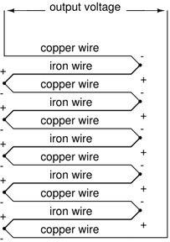
Working: These Thermo-couples are arranged throughout the cold & hot areas of the arrangement where the hot junctions are isolated thermally from the cold junctions. In reply to the temperature variation across the material, the output voltage of the Thermo-pile is called a Seebeck coefficient or Thermo-electric coefficient. So, it is measured volts per kelvin (V/K) otherwise mV/K.

Thermo-pile advantages
  - It doesn’t need an external power supply.
  - It gives a stable response to radiation which is emitted from temperature-measuring bodies.
  - It has stable response characteristics.
  - Thermo-pile is a non-contact temperature-detecting device that uses IR radiation to transfer heat.
  - These are available in small sizes.
  - It is less costly.
  - It generates larger o/p voltage because of the usage of several Thermo-couple devices.

Thermo-pile disadvantages
  - These are static, so unused ones should be stored within conductive material to defend them from static discharges & static fields.
  - These can be damaged due to stress and reverse the polarity of the supply.
  - These should not be directly exposed to moisture or sunlight because this may harm or will have corrosion on the device’s performance.
  - This device should not be operated with dirty or oily fingers because this dust will affect the device’s performance. For superior performance, we need to clean with cotton swabs or alcohol.
  - For precise temperature measurement, an object should fill the field of view completely of the Thermo-pile device.

Thermo-electric generators (TEG):
Thermo-electric is a word which is the combination of words electric and thermo. So, the name signifies that thermal corresponds to heat energy and electricity corresponds to electrical energy. Thermo-electric generators are the devices that are implemented in the conversion of the temperature difference that is generated between the two sections into the electrical form of energy. This is the basic Thermo-electric generator definition.
These devices are dependent on the Thermo-electric effects which involve interface that happens between heat flow and the electricity through solid components.
Principle: The Seebeck effect forms the basis for power generation. Thermo-electric generators convert heat energy to electricity. When a temperature gradient is created across the Thermo-electric device, a DC voltage develops across the terminals. When a load is properly connected, electrical current flows. Typical applications for this technology include providing power for remote telecommunication, navigations, and petroleum installations.
As early as 1929, A. F. Ioffe (1880-1960) showed that a Thermo-electric generator utilizing semiconductors could achieve a conversion efficiency of 4%, with further possible improvement in its performance.
Construction: The simplest Thermo-electric generator consists of a Thermo-couple, comprising a p-type and n-type Thermo-element connected electrically in series and thermally in parallel (Fig). The P-type and N-type semiconductors are interconnected through a metal. Load is connected to free end of P and N type semiconductors. To design such Thermo-electric generators, semiconductors are used which have high electrical conductivity and low thermal conductivity.

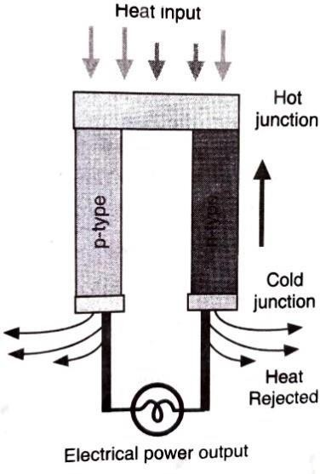

Working:
Heat is pumped into one side of the couple and rejected from the opposite side. The electrons present at the hot end would be at a high energy level as compared to electrons present at the cool end side. This means that the hot electrons will tend to move towards the cool end due to the temperature gradient. When a temperature gradient is produced between two ends, the electrons start flowing from one end to another end and create a potential difference. An electrical current is produced, proportional to the temperature gradient between the hot and cold junctions.
Of the great number of materials studied, semiconductors based on bismuth telluride, lead telluride and silicon-germanium alloys are found to be the best.
Thermo-electric Generator Applications:
- For enhancing the fuel performance of cars, the TEG device is mostly employed. These generators make use of heat that is generated at the time of vehicle operation
- Seebeck Power Generation is utilized to provide power for the spacecraft.
- Thermo-electric generators are implemented to provide power for the remote stations such as weather systems, relay networks, and others.

Thermo-electric coolers:
Thermo-electric coolers are solid state heat pumps used in applications where temperature stabilization, temperature cycling, or cooling below ambient are required.

Principle: The principle used in this is Peltier effect. i.e. ‘when electric current passed
in a circuit consisting of two dissimilar metals, heat is evolved at one junction and absorbed at the other junction.’
Construction: A Thermo-electric cooling arrangement is as shown in figure. It consists of a Thermo-electric module, a heat sink and the object to be cooled. A typical Thermo-electric module consists of an array of bismuth telluride semiconductor pellets that have been “doped” so that one type of charge carrier-either positive or negative carries the majority of current. The pairs of P/N pellets are configured so that they are connected electrically in series, but thermally in parallel. Metalized ceramic substrates provide the platform for the pellets and the small conductive tabs that connect them. The ceramic material on both sides of the Thermo-electric adds rigidity and the necessary electrical insulation. The pellets, tabs and substrates thus form a layered configuration. Module size varies from less than 0.25” by 0.25” to approximately 2.0” by 2.0”. Thermo-electric modules can function singularly or in groups with either series, parallel, or series/parallel electrical connections. Some applications use stacked multi-stage modules.

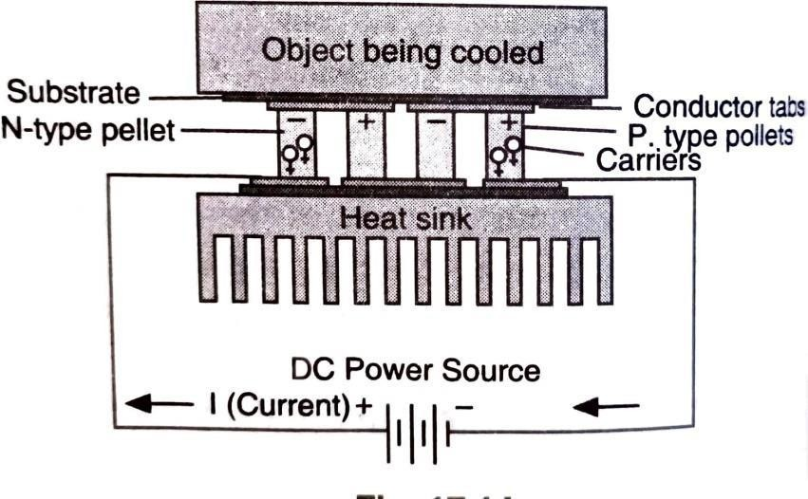

Working: When DC voltage is applied to the module, the positive and negative charge carriers in the pellet array absorb heat energy from one substrate surface and release it to the substrate at the opposite side. The surface where heat energy is absorbed becomes cold the opposite surface where heat energy is released, becomes hot.
These devices cannot only pump appreciable amount of heat, but with their series electrical connection, are suitable to be used as DC power supplies. Thus, the most common Thermo-electric devices now in use connecting 254 alternating P and N-type pellets can run from a 12 to 16 VDC supply and draw only 4 to 5 amps. A means to mechanically hold everything together is to mount the conductive tabs to thin ceramic substrates (Fig) the outer faces of the ceramics are then used as the thermal interface between Peltier device and the ‘outside world’. Ceramic materials represent the best compromise between mechanical strength, electrical resistivity, and thermal conductivity.

Cryogenics:
Production of low temperature:
Cryogenics is defined as that branch of physics which deals with the production of very low temperatures and their effect on matter, a formulation which addresses both aspects of attaining low temperatures which do not naturally occur on Earth, and of using them for the study of nature or the human industry. In a more operational way, it is also defined as the science and technology of temperatures below 120 K. The limit temperature of 120 K comprehensively includes the normal boiling points of the main atmospheric gases, as well as of methane which constitutes the principal component of natural gas. Today, liquid natural gas (LNG) represents one of the largest – and fast-growing – industrial domains of application of cryogenics, together with the liquefaction and separation of air gases.
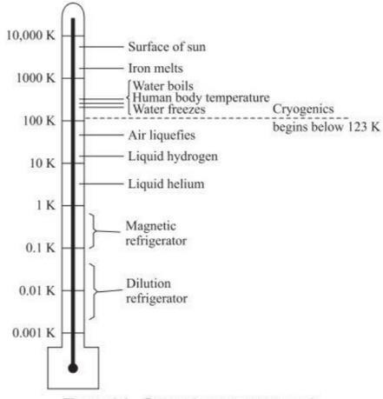
Cryogenic temperature scale

Joule Thomson effect:
Statement: If a gas initially at constant high pressure is allowed to suffer throttle expansion through the porous plug of silk, wool or cotton wool having a number of fine pores, to a region of constant low pressure adiabatically, a change in temperature of gas (either cooling or heating) is observed. This effect is called Joule –Thomson or Joule-Kelvin effect.

Theory of Joule Thomson effect:
Suppose that one mole of gas is allowed to expand through a porous plug from a pressure P1 and volume V1 to a pressure P2 and volume V2. Let the temperature change from T1 to T2 due to Joule-Thomson effect.
Net external work done by the gas = P2V2 – P1V1 -- (1)
Now, an internal work is also done by the gas in overcoming the forces of molecular attraction. For a van der Waals gas, the attractive forces between the molecules are equivalent to an internal pressure = , a is constant

Internal work done by the gas when the gas expands from a volume V1 to V2 is
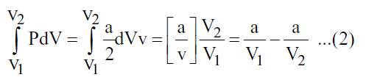
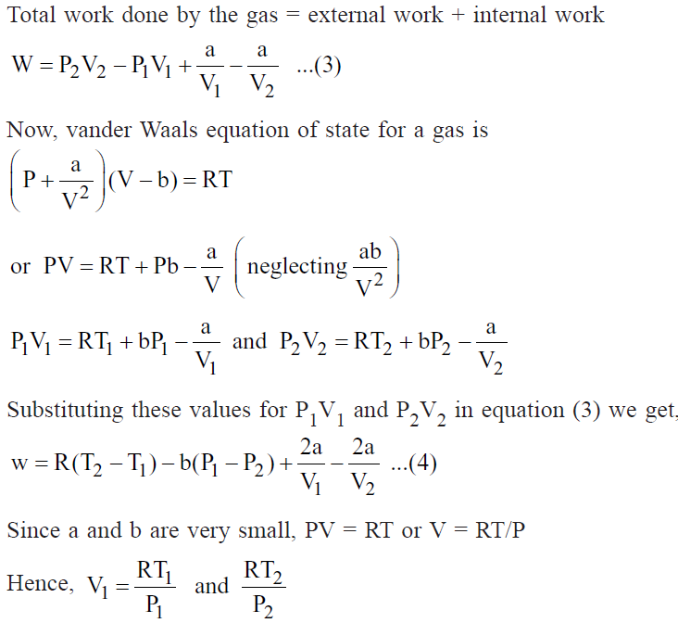

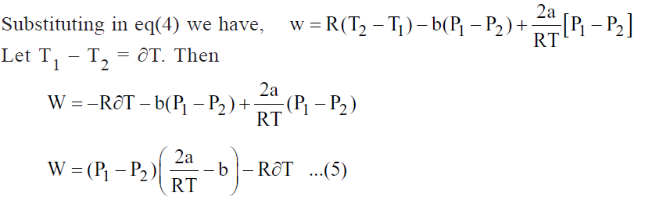

Since the gas is thermally insulated, the expansion leads to decreases in temperature ∂T and heat lost by the gas is given by
W = Cv ∂T

Thus equation (5) becomes
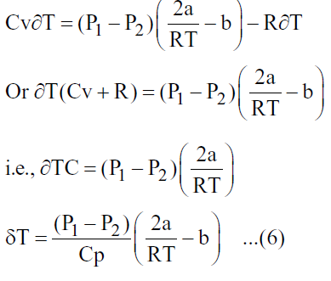
Thus, the Joule-Thomson Co-efficient is given by
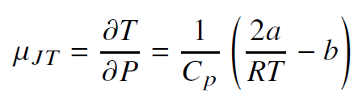

Equation (6) gives the fall in temperature or the cooling produced in a van der Waals gas when subjected to throttling process.

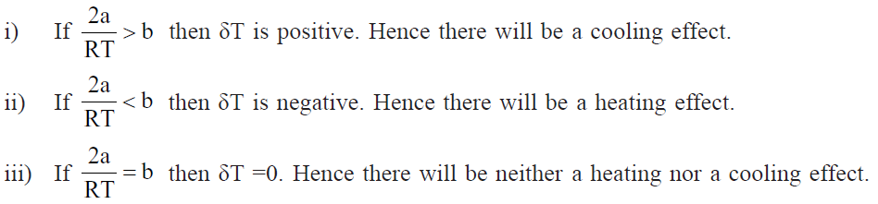

Porous Plug experiment
Construction:
Joule in collaboration with Thomson [Lord Kelvin] devised a very sensitive technique known as Porous Plug experiment. The experiment setup of porous plug experiment to study the Joule-Thomson effect is shown in Figure. It consists of the following main parts:

- A Porous plug having two perforated brass discs D & D1.
- The space between D & D1 is placed with cotton wool or silk fibres.
- The porous plug is fitted in a cylindrical box-wood W which is surrounded by a vessel containing cotton wool. This is to avoid loss or gain of heat from the surroundings.
- T1 &T2 are two sensitive platinum resistance thermometers and they measure the temperatures of the incoming and outgoing gas.
The gas is compressed to a high pressure with the help of piston P and it is placed through a spiral tube immersed in water bath maintained at a constant temperature. If there is any heating of the gas due to compression, this heat is absorbed by the circulating water in the water bath.

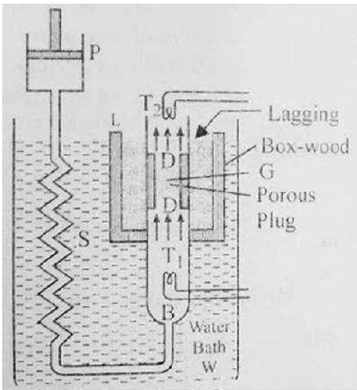

Experimental Procedure
The experimental gas is compressed by Pump P and is passed slowly and uniformly through the porous plug keeping the high-pressure constant read by pressure gauge. During the passage through the porous plug, the gas is throttled. The separation between the molecules increases. By passing through the porous plug, the volume of the gas increases against the atmospheric pressure. As there is no loss or gain of heat during the whole process, the expansion of the gas takes place adiabatically. The initial and final temperatures are noted by platinum resistance thermometers T1 & T2.

Experimental Results
A simple arrangement of porous plug experiment is shown in Figure. The behaviour of large number of gases was studied at various inlet temperatures of the gas and the results are as follows:
- At sufficiently low temperatures, all gases show a cooling effect.
- At ordinary temperatures, all gases except hydrogen and helium show cooling effect. Hydrogen and Helium show heating effect.
- The fall in temperature is directly proportional to the difference in pressure on the two sides of porous plug.

The fall in temperature for a given difference decreases with rise in the initial temperature of the gas. It was found that the cooling effect decreased with the increase of initial temperature and becomes zero at a certain temperature and at a temperature higher than the temperature instead of cooling heating was observed. This particular temperature at which the Joule – Thomson effect changes sign is called temperature of inversion.
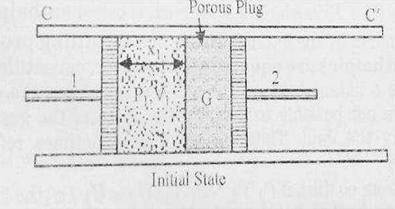

Linde’s air liquefier:
Principle: Linde’s process is known as adiabatic expansion
of compressed gas. The process is based upon the combined effect of Joule – Thomson Effect and regenerative cooling. The compressed gas is made to expand adiabatically and repeatedly.

Construction:
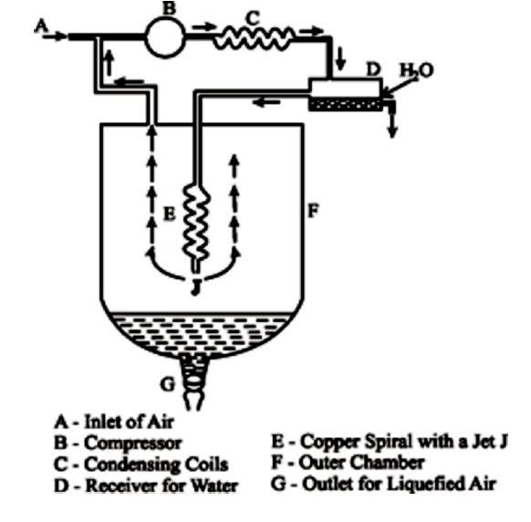
Process:
• The air is first compressed to about 200 atmospheres in the compressor and then passed through the condensing coils.
• As a result, the air is cooled and the water vapours present condense to form the water which is removed from receiver.
• The dry air is then passed through the spiral copper tube which terminates into a jet.
• The air expands through the jet into the chamber where pressure is about 50 atmospheres.
• Thus, as a result of Joule-Thomson effect, the air is cooled.
• As this cooled air moves up, it further cools the incoming air.
• The cooled air is sent to the compressor again and the process is repeated a number of times till ultimately the air is cooled to such an extent that it liquefies.
• The liquefied air gets collected at the bottom of the outer chamber and can be drawn off. Any uncondensed air is recirculated.

Liquefaction of Helium:
Claude’s method is a prominent technique for the liquefaction of helium, particularly effective due to helium’s very low boiling point and unique Thermo-dynamic properties. This method utilizes a combination of the Joule-Thomson effect and multiple stages of cooling to achieve liquefaction. Here’s a detailed overview of the process.
Helium is the only substance which remains fluid at temperatures below -259ºC (4K) and its inversion point is much lower than that of Hydrogen namely around -233ºC(40K). The boiling point of Helium is just around -267ºC which is quite close to absolute zero on the Kelvin scale
Principle: Claude’s method works on two principles. i.e. Joule Thomson effect and mechanical expansion (using an expansion turbine).

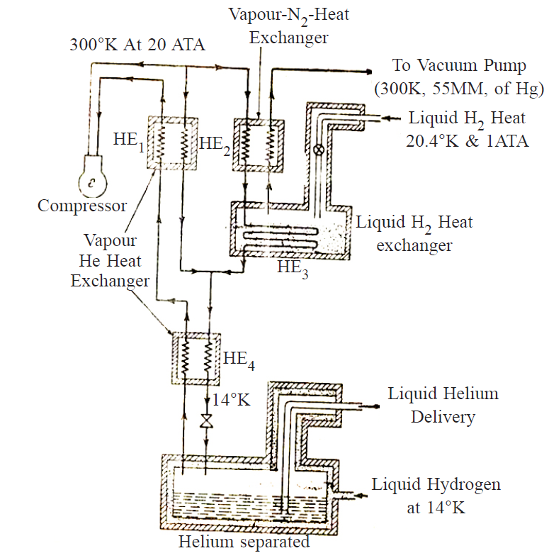
Working:

- Initially Helium is compressed to a pressure of 20 atmospheres which raises its temperature to the region of 300 degrees Kelvin.
- This compressed high temperature Helium is then split into two paths.
- The first part is cooled in the heat exchanger labelled HE1 with the help of Helium vapours
- The other part passes through the heat exchanger HE2 to be cooled with Hydrogen vapours.
- Both these streams combine to be passed through the liquid Hydrogen heat exchanger HE3
- Then again getting cooled in HE4 by Helium vapours.
- Finally, the throttle valve is used to initiate the Joule Thomson effect and Helium is collected in the liquid state in the Helium separator.

Adiabatic demagnetization:
Adiabatic Demagnetization is a cooling technique used in low-temperature physics to reach temperatures much lower than what can be achieved by conventional refrigeration.
Adiabatic demagnetisation is a process used to achieve extremely low temperatures (in the milli-kelvin range) by making use of the magnetic properties of certain materials, typically paramagnetic salts.

Certain salts like gadolinium sulphate, cerium magnesium nitrate, etc. contain magnetic dipoles. When placed in a strong external magnetic field, these dipoles tend to align with the field, lowering their magnetic entropy.
As the field decreases, dipoles tend to randomize, which increases magnetic entropy. But since the process is adiabatic, total entropy is conserved → the increase in magnetic entropy must be compensated by a decrease in lattice (thermal) entropy, i.e., the temperature of the system drops. The material becomes much colder, often reaching temperatures below 0.1 K.

Applications of Cryogenics:
Aerospace:

For critical components in the aerospace industry the cryogenic hardening can be used to strengthen metal parts in communications systems, guidance systems, landing gear, and more.

Using cryogenic hardening to prep critical components may help the rover survive these bitter cold conditions of lunar night.

Cryogenics is used to design the multi-layer insulation blankets to insulate the spacecraft.

Cryogenic engine makes use of Liquid Oxygen (LOX) and Liquid Hydrogen (LH2) as propellants which liquefy at -183ºC and -253ºC respectively.

Tribology - Cryogenic Treatment of Metals

Cryogenic processing (Cryogenic Treatment) typically entails a slow cooling to cryogenic temperatures, a dwell period at this low temperature followed by a slow return to room temperature and finally a first stage tempering.

The cryogenic hardening for steel induces a phase transformation from austenite to martensite, among other changes. This improves qualities such as hard- ness, electrical conductivity, wear resistance, lowering friction and susceptibility to corrosion

Cryogenic treatment works increases life of the tools like Reamers, Tool bits, Tool punches, Car- bide Drills, Carbide Cutters, Milling Cutters, Files, Knives, Reciprocating Blades, Dies and cutting tools.

Stress relieved ferrous and non-ferrous castings and forgings for enhanced dimensional stability and sur- face finish.

Food Processing
      - Cryogenic quick freezer is widely used in the food cold chain resulting from the better quality of frozen food.
      - Due to the rapid freezing rate, water in food will become total or partial vitrification with cryogenic technology.
      - Liquid nitrogen (LN2) is used in the freezing process of food.
      - Cryogenics is also used transportation of large masses of frozen food.
      - Cryogenic food freezing is also helpful for large scale food processing industries

